OnionEdge Getting Started

The Omega Onion is a 32 bit computer running OpenWRT Linux with a 400 Mhz MIPS Atheros processor and 64 MB RAM and 16MB flash storage. This guide covers the installation of the OnionEdge program which will allow the GPIO pins of the Onion to be integrated with Thingworx.

# Notes

This edge server supports only binary input and output from sensors. It also supports the DHT11 and DHT22 temperature sensor.

The OnionEdge comes in two versions. The OnionEdgeTLS uses secure sockets but the OnionEdgeNoTLS does not.

If you are using a system other than windows you can follow and merge the instructions at <https://wiki.onion.io/Get-Started> with the ones in this document.

# Setting up the Onion

1. To use the OnionEdge you need the following:
   1. USB Micro cable
   2. Omega chip and the expansion dock
   3. Binary output sensor like a LED
   4. Binary input sensor like a Switch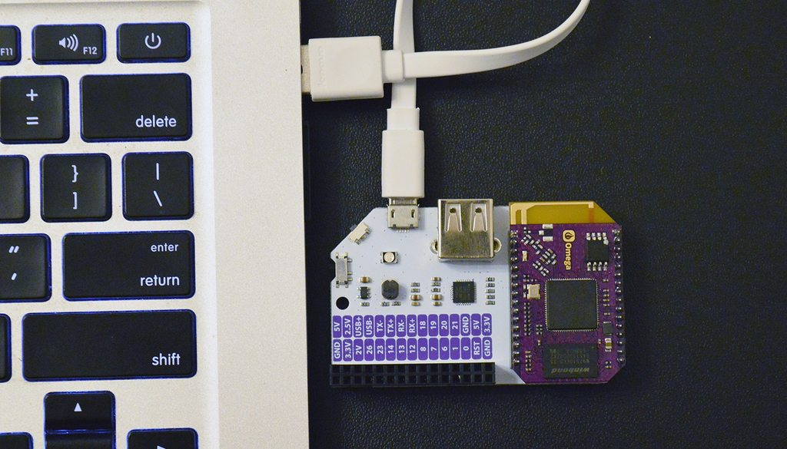
2. Insert the omega chip into the expansion dock. The chip pins should go in all the way such that you cannot see them. This may require some force.
3. Install the USB to serial driver from https://www.silabs.com/Support%20Documents/Software/CP210x_VCP_Windows.zip
4. Connect the Onion to the PC with the USB micro cable. Move the switch in the corner to turn omega on if it isn’t already.
5. While the Onion is starting up and activating wifi there will be blinking lights next to the large USB port on the board
6. Run Device Manager (Start > type “Device Manager” and press ENTER), look for Usb to Serial Comm Port under Ports (COM & LPT), and take note of the COM number in bracket.

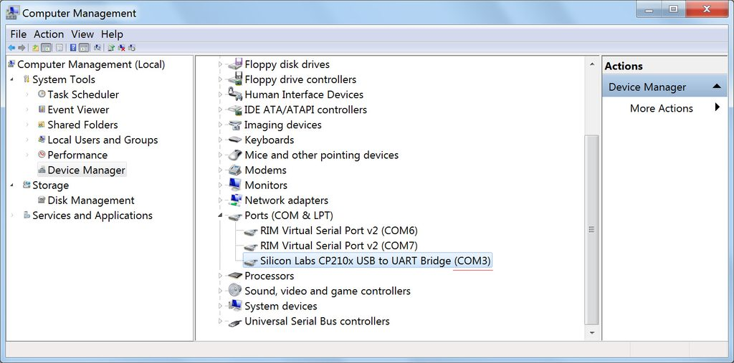

1. Start putty.exe, from the desktop.
2. You will need to configure Putty to connect to your Onion Omega.
   1. Set the serial port to whichever port your USB to Serial driver was installed to
   2. Set the speed to 115200
   3. Click open

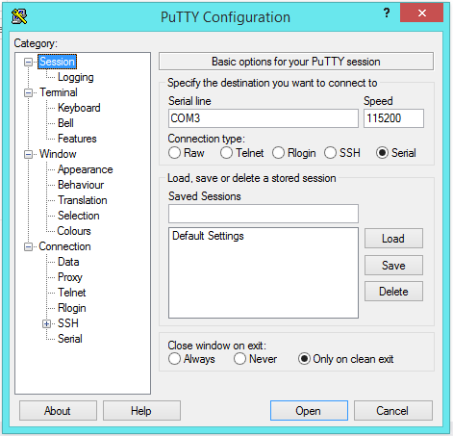

1. Putty will then open up a command prompt. Press enter if you don’t see the Onion logo.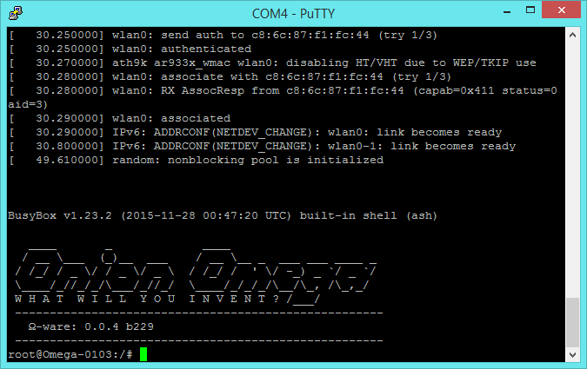
2. The Onion is a router that has its own static IP address 192.168.3.1 by default so make sure you don’t have a conflicting IP address on your network.
3. Connect your computer to the Onions’ wifi network. The network name is in the command line of the putty window “Omega-0103” in this case.
4. Run ipconfig in the command line of your computer to get the IP address the onion assigned to it.
5. Now run winscp from your windows desktop. Select protocol SCP, hostname 192.168.3.1, Username root, password onioneer and log in. Then copy the OnionEdge and config.txt files to the onion.

(If you are using a terminal the command is, for example: scp filename root@ipaddress:~)

1. In the putty window change directory to the /root directory: cd ~
2. You will need to configure the Onion Agent before starting it. Use vi (or other text editor) to edit the file: vi config.txt

To edit the text press the I key, INSERT will appear in the lower left.

* 1. Replace the IP address on the second line with that of your computer.
     1. Click start>run>cmd.exe
     2. Type ipconfig and note the ip address of the Wi-Fi adapter
     3. Highlight it with your mouse and press crtl c to copy
     4. Move the cursor with the arrow keys in VI and right click to paste
  2. Replace the app key in the third line with the one you copied from the Installing Thingworx tutorial
  3. Any lines starting with a hash (#) will be ignored
  4. Delete any hidden characters (they might show up as ^M at the end of a line)

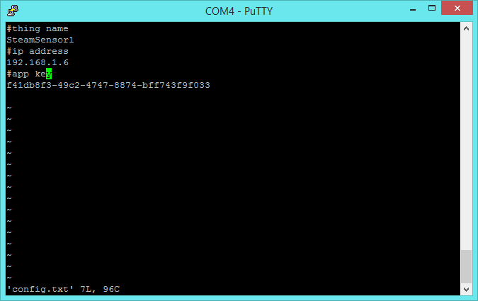

1. To save changes and quit in vi, press “Esc” then type :wq and press Enter. You should be back at the command prompt.
2. You may need to set execute permissions for the OnionEdge file. Type chmod +x OnionEdge
3. To start this edge client use the following command: ./OnionEdge
4. From here you will see a lot of output pertaining to settings and connection progress. You will now need to access your Thingworx instance.
5. You can run the Shutdown service in Thingworx stop the OnionEdge program

# Setting up your local ThingWorx server

**Setup**

1. Make a new thing with the same name as the second line in your config.txt file
2. Extend from remote thing and click save
3. To see if the remote thing has been bound, click on the Monitoring menu on the top left and select Remote Things. The Unbound tab will show any edge devices not yet associated with a Thing.